Operational Processes – POS (Point of Service) role (Covid 19 Vaccines)
Covid 19 Vaccine Clinic roles and system usage guide for NHS Trusts
Contents
1 Definition and Purpose 3
2 Preparing to Use the SimplyBook System 3
2.1 Requesting access for new users 3
2.2 Email received by POS advising of system access 3
2.3 System web access / URL 4
2.4 First logon (using email link) 4
2.5 Logging in to SimplyBook 4
2.6 Setting a new password for the system 5
2.7 Password resets and Requesting a new password 5
2.8 Making Sure to Log out of the System 5
3 Creating 2nd appointments in clinic for staff/patients at time of 1st vaccine 6
3.1 Checking the Validation Status of the current booking 6
3.2 Making a 2nd Appointment 7
4 If the Staff/patient arrives for their appointment without their Ticket 8
5 How to facilitate a Walk-in Staff/Patient (without an appointment) 9
5.1 Dealing with Walk-ins 9
6 Amending a Booking 10
6.1 Amending a booking time – same date appointments 10
6.2 Amending a booking date and, or, booking date and time 10
6.3 Amending a booking date and, or, booking date and time – Alternative Method 11
7 Cancelling a Booking 12
7.1 Cancelling an appointment 12

- Definition and Purpose
The system Book system has the following roles associated to it.
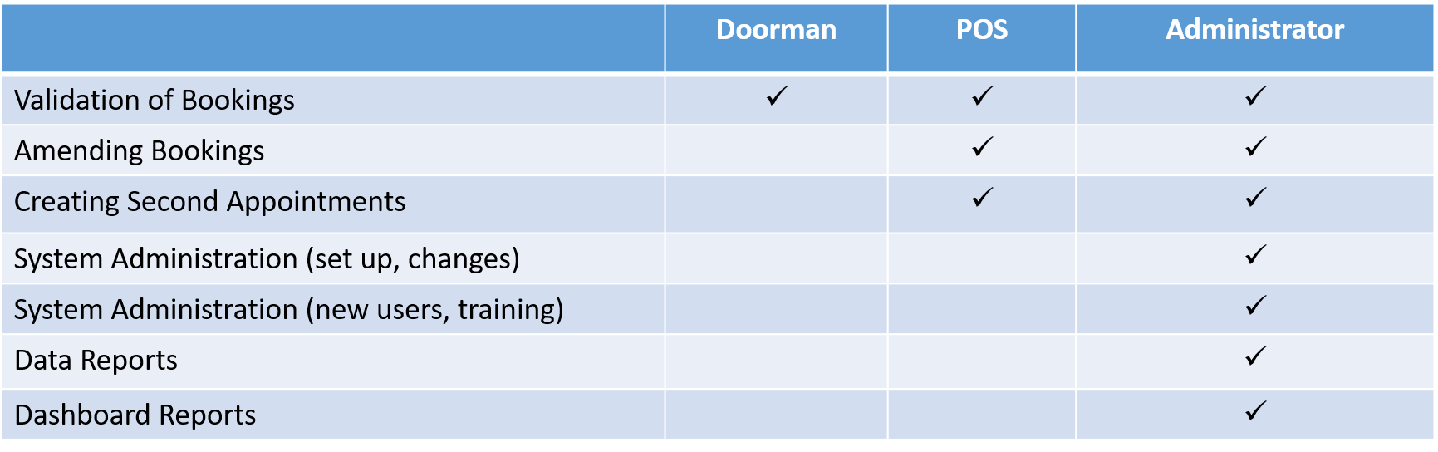
This booklet sets out the operational processes for the Covid 19 Vaccine clinic - POS role.
The POS role is responsible for checking that 1st appointments have been validated prior to booking the 2nd appointment, amending appointments dealing with walk in’s (i.e. Staff/patients requiring a vaccine without a booked appointment).
Should you not be able to find the support you require within this document, please contact the [Enter relevant email address] mailbox, where one of the team will be able to assist.
- Preparing to Use the SimplyBook System
  - Requesting access for new users
To request access for new users, please contact the [Enter relevant email address] mailbox and provide the following information for the new user:
- Full Name
- Email Address
- Contact phone number
- Type of access – i.e. Role & description of how the new user will be using the system – i.e. POS – managing appointments.
Once actioned by the team, the new user will obtain an email with their joining instructions.
  - Email received by POS advising of system access
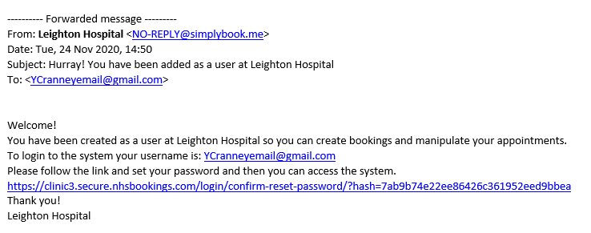

  - System web access / URL
The web address for the SimplyBook administration log in screen is in your email.
Copy and paste it into Chrome, press enter and save it as a favourite (or access via favourites).
Note: It is important that you open the application in Chrome for full functionality.

  - First logon (using email link)
When you click on the link provided in the email the following screen appears

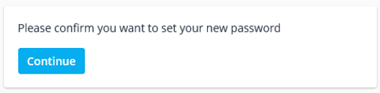
Click Continue, the next box appears.

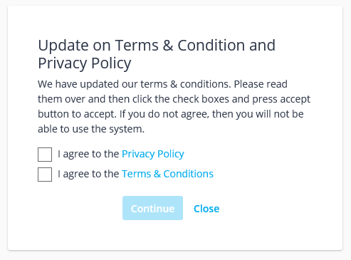
Agree to privacy and T&C’s (tick the boxes & click Continue).

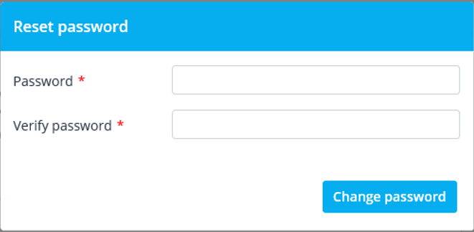

For security reasons, set a new password for your login.

  - Logging in to SimplyBook
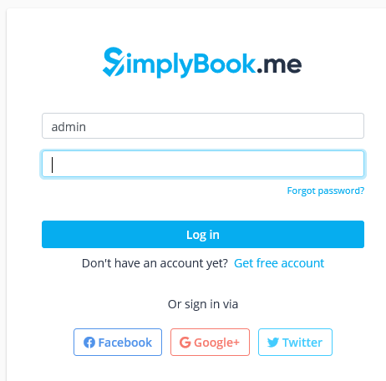
Enter the following information to log you in:

Username = Your organisational Email Address

Password = will be provided via email

  - Setting a new password for the system
If you are not prompted to change your password on first logon, please do the following;
Once you have successfully entered the system, click on the three horizontal bars in the top left of the screen and click ‘Settings’.
You will now need to click on ‘change password’ and follow the steps to make the changes.
It is important that you do this and remember your password.
To ensure a high level of system security your password will need to fulfil a level of complexity:

- 15 x characters
- Must include upper and lower case
- And digit/special characters
  - Password resets and Requesting a new password
There is a security policy in place for login which allows 5 attempts, if exceeded the system will temporarily block access to the username. If this happens please check that you are using the correct password and that Caps Lock is not on etc., then try again after 5 minutes.
If you have forgotten your password, click on the ‘forgot password’ link at the log in screen, or email [Enter relevant email address] for support.
  - Setting Up Google Authenticator
As you are able to access Patient Identifiable Details (PID), you will need to add an additional layer of security to your account.
Google Authenticator is a 6 – digit access code, which changes every 30 seconds.
To add Google Authenticator to your account, first download this from the app store/ google play on to your mobile.
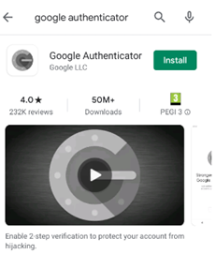
- https://play.google.com/store/apps/details?id=com.google.android.apps.authenticator2&hl=en_GB
- https://apps.apple.com/us/app/google-authenticator/id388497605
Whilst logged into the Simplybook website, click on the ‘Welcome’ page (from the side menu bar).
This will display your account information on the right hand side of the screen.
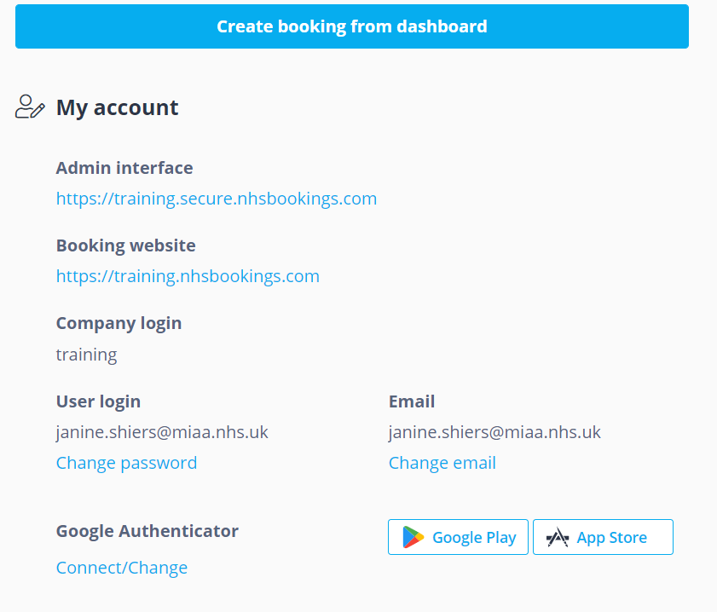
Click on ‘Connect/Change’ under Google Authenticator.
This will bring up a QR code, or a key number.
Using the Google Authenticator app, scan the QR code or enter the key number, to add a new account.
This will create a new account on Google Authenticator, and a 6 digit code. This 6 digit code is refreshed every 30 seconds, so you must not delete this account otherwise you will not be able to access your Simplybook account.
The next time you log into the Simplybook system, and app if using, you will also be prompted to enter the Google Authenticator 6 digit code.
  - Making Sure to Log out of the System
You must always ensure that you log out of the system at the end of your shift.
If you do not do this, then you will remain logged in, and other Service Providers may use your log in details to record their work which is NOT best practice.
It is therefore your responsibility to log yourself out of the system at the end of you shift.
Click on your username (top right) and click ‘log out’.

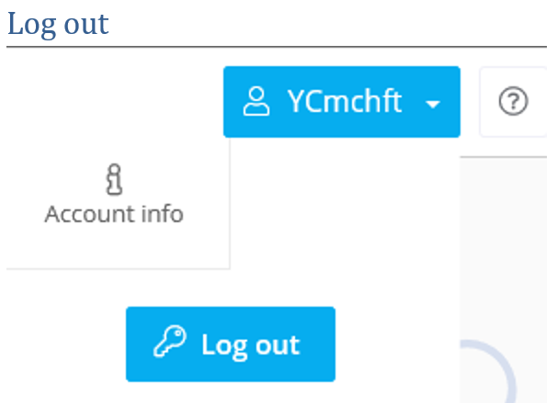
- Creating 2nd appointments in clinic for staff/patients at time of 1st vaccine
On arrival for an appointment the service user (Patient/Staff) will need to have their appointment booking ticket. This could be in paper or electronic format. 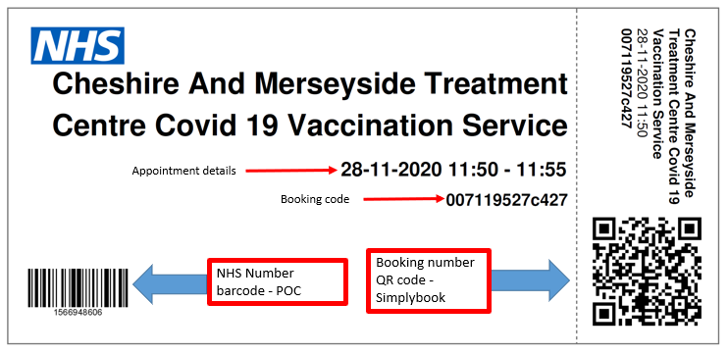
The POS;
- Supports real time clinic activities by;
  - Checking validation of 1st appointment attended.
  - Books 2nd follow up vaccine appointment for a staff/patient who has just had the 1st vaccine.

  - Checking the Validation Status of the current booking
For users with POS access and above

Log onto SimplyBook via Chrome.

Before making a follow up appointment, it is necessary to check that the first appointment was ‘validated’.
Open your Simplybook account from the admin interface (using a website link).
On the Calendar screen click on the Validate ticket button.

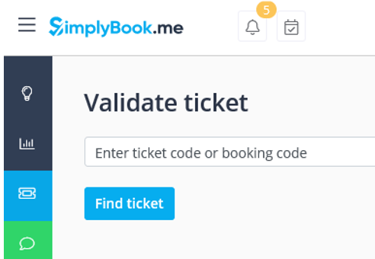
Click into the ‘Validate Ticket’ field and use the scanner to scan the QR code.
This is best practice and the safest way to avoid manual entry errors.
However, you can key in the code if necessary.
Once the code shows in the field, click Find Ticket and the appointment should appear beneath the Find Ticket.

IF this does NOT appear – check you are using Chrome as your browser.
If a ticket has already been validated there will not be an option to ‘Validate Ticket’. If a ticket has not been Validated, click ‘Validate Ticket’

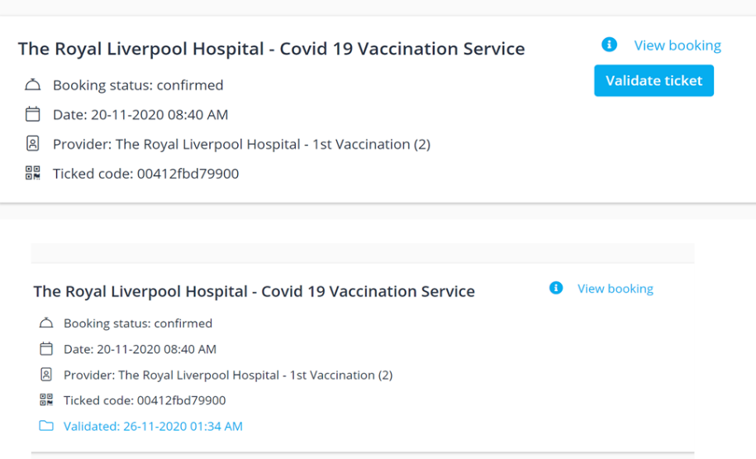

  - Making a 2nd Appointment
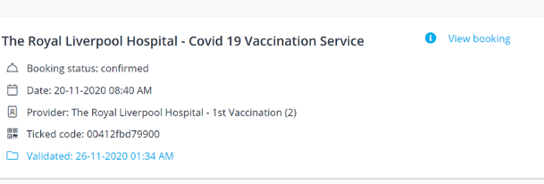
Click ‘View Booking’ and scroll to the bottom.
Click the ‘Rebook’ button.

This opens a copy of the first appointment booking, correctly associating the patient details and linking both appointments.
You will need to amend the details to those required for the 2nd vaccine appointment.
Firstly, Change the Service Provider from ‘1st’ to ‘2nd vaccination’ calendar via the search icon.

Next, Change the date of the appointment.
To do this, click on the first date & time link next to Start time.

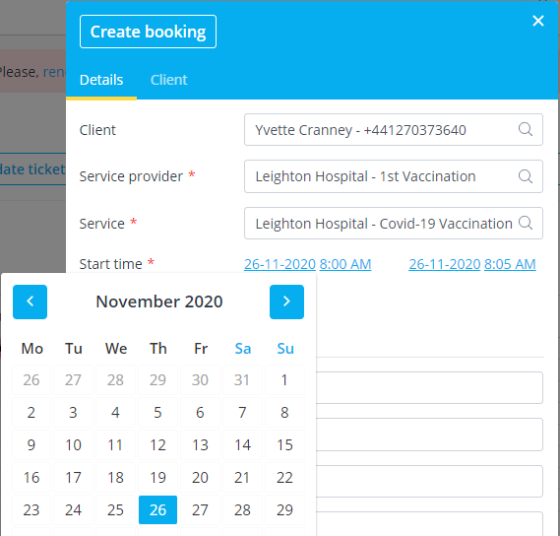
This will open a calendar.

Select the date set for the correct time delay – this will be determined by the vaccine type the user has just received.
Enter an appointment start time (ideally for the same time).

Click ‘Save’ (*If the selected date and/or time is not available, an error message will appear)

- If the Staff/patient arrives for their appointment without their Ticket
If the user does not have their appointment Ticket or booking code the POS can locate the booking in the calendar view.
Double click on the correct appointment to open the booking.
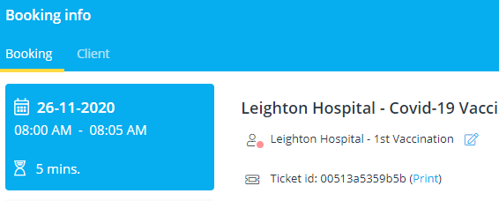
The Ticket id code is the booking reference number.

The POS can either Validate the appointment themselves or pass the booking ref number across to the Doorman for Validation to occur. Depending on clinic resources and flow on the day.

- How to facilitate a Walk-in Staff/Patient (without an appointment)
It is incredibly important that NHS capacity is managed effectively and unnecessary wastage of vaccines (which may have limited shelf life) is avoided as much as possible.
It is therefore important that everyone who books an appointment attends and that the attendance or DNA is recorded on the system.
The SimplyBook system functionality for Covid 19 vaccine bookings is designed to support bookings made in advance by the service users (Patient/staff) booking via a special link, which will have been sent out to them via email. It will not function correctly if bookings are attempted to be made directly into SimplyBook by the clinic staff. However, it is acknowledged that if spare spaces and vaccines are available the Trust may want to ensure they are used up, therefore a workaround process has been devised.
  - Dealing with Walk-ins
If a member of staff presents at your Covid 19 vaccination site without a booked appointment, the Doorman should advise the POS. If a decision is made to provide vaccination, it is important to ensure that each booking made, is linked to the NIMS database to ensure that patient immunisation details are accurately recorded on the booking system. In order to facilitate a walk-in appointment, users will need to know their NHS Number.
    - Making a 1st Time Appointment
For users with POS access and above
Open your Simplybook account from the admin interface (using a website link).
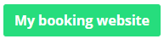
Click on the green ‘My Booking Website’ icon located at the top right corner of the screen.

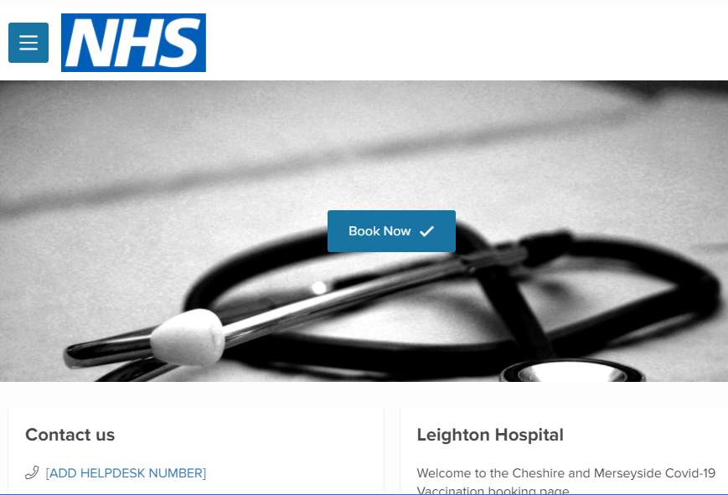
This opens the staff/patient booking site.
Click ‘Book Now’
Select the first available appointment slot
Complete the intake questions with the service user (Staff/patient).
Check the ‘Terms and Conditions’ box
Then click ‘Confirm Booking’

    - Assign the Vaccine Type to the booking
For users with POS access and above
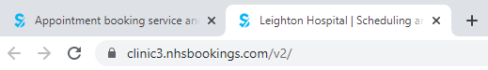
Click on the previous browser tab (at top of screen) to return to the SimplyBook admin interface.
Select ‘Calendar’ from the sidebar menu, and find the appointment just created.
Double click the appointment to open it and Make a note of the Booking code.
Click on ‘Edit’ at the bottom of the booking details screen.

In the field ‘Chosen Covid Vaccine Type’ enter the name of the vaccine the clinic will be delivering for the 1st vaccination.
Click ‘Save’.
    - Validate the Booking
For users with POS access and above
Select ‘Validate Ticket’
Enter the booking code into the search bar
Click ‘Find Ticket’
Scroll to the bottom of the screen
Click ‘Validate Ticket’
The Staff/Patient is now ready to receive a covid-19 1st vaccination.
- Amending a Booking
  - Amending a booking time – same date appointments
For users with POS access and above
Open your Simplybook account from the admin interface (using a website link).
Select Calendar from the sidebar menu
Locate the booking from the calendar screen by using the mouse cursor to hoover over the entries to produce a pop-up with the booking details.
Once the booking to be amended has been identifed, using the left button on the mouse, drag the entry to the new time slot.
When prompted ‘Are you sure you want to change this booking?’, click ‘Yes’
Users will need to be notifed by the clinic of this time change. Their booking number remains unchanged.

  - Amending a booking date and, or, booking date and time
For users with POS access and above
Open your Simplybook account from the admin interface (using a website link).
Select Calendar from the sidebar menu
Locate the booking from the calendar screen by using the mouse cursor to hoover over the entries to produce a pop up with the booking details.
Once the booking to be amended has been identified, click ‘Edit’
Amend the start date, and or time (the left hand-side details):
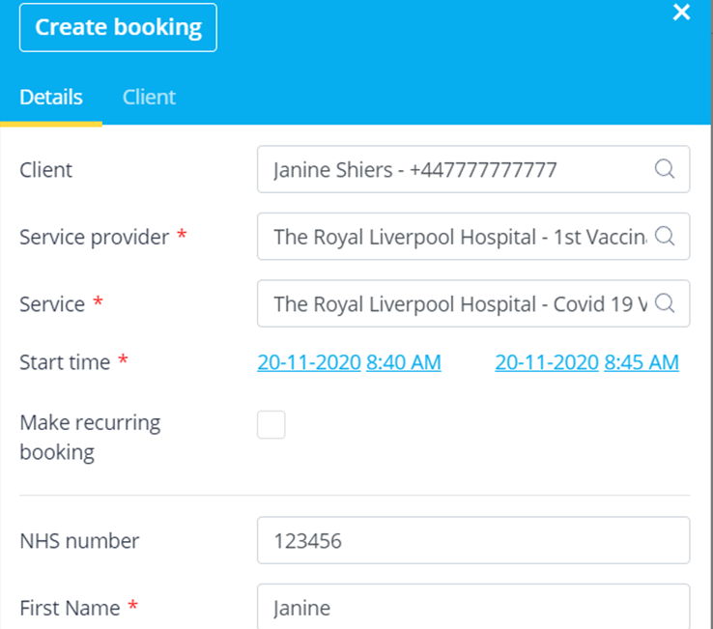
Click ‘Save’ (*If the selected date and/or time is not available, an error message will appear)
Users will need to be notifed by the clinic of this time change. Their booking number remains unchanged.

  - Amending a booking date and, or, booking date and time – Alternative Method
For users with POS access and above.
Open your Simplybook account from the admin interface (using a website link).
Select Calendar from the sidebar menu, and then Validate Ticket.
Enter the ticket number/booking code into the search bar, and click ‘Find Ticket’
Scroll to the bottom of the screen, where the booking details will appear:
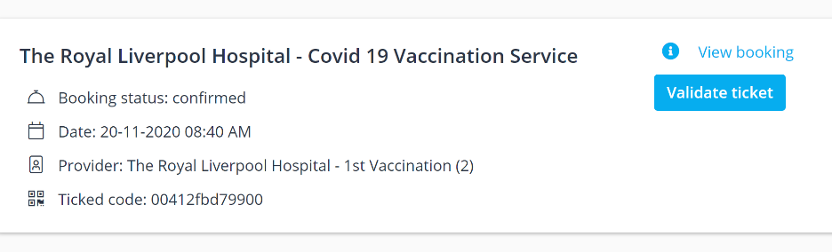
Click ‘View Booking’

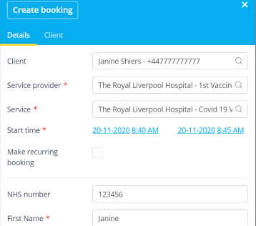
Amend the start date and/or time by clicking the left hand ‘Start time’ details and selecting from the calendar.
Click ‘Save’ (*If the selected date, and or time is not available, and error message will appear)
Users will need to be notifed by the clinic of this time change. Their booking number remains unchanged.
- Cancelling a Booking
  - Cancelling an appointment
For users with POS access and above.
Open your Simplybook account from the admin interface (using a website link).
Select Calendar from the sidebar menu
Locate the booking from the calendar screen by using the mouse cursor to hoover over the entries to produce a pop up with the booking details.
Once the booking to be cancelled has been identified, make a note of the booking code (or copy by holding down the left mouse button, highlighting the code and right click and ‘copy’)
Select Validate Ticket.
Enter the booking code into the search bar, and click ‘Find Ticket’
Scroll to the bottom of the screen, where the booking details will appear:
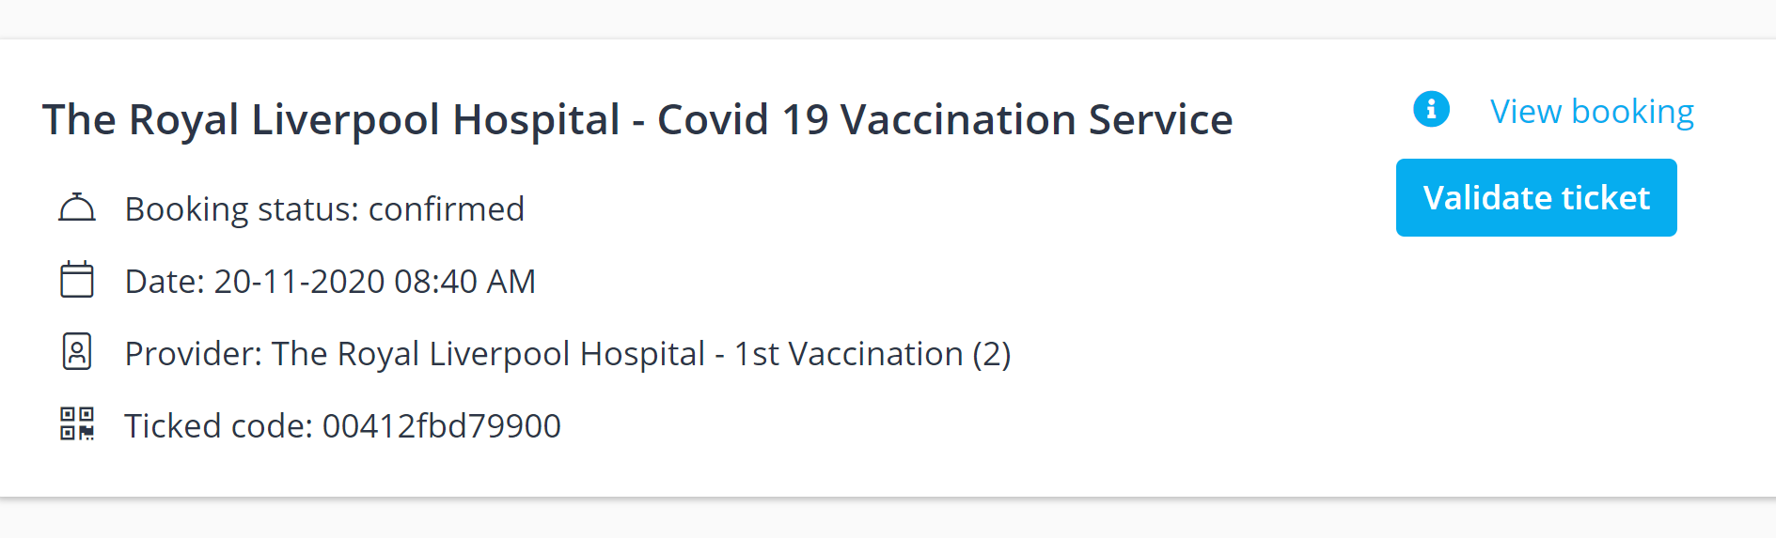
Click ‘View Booking’, and scroll to the bottom
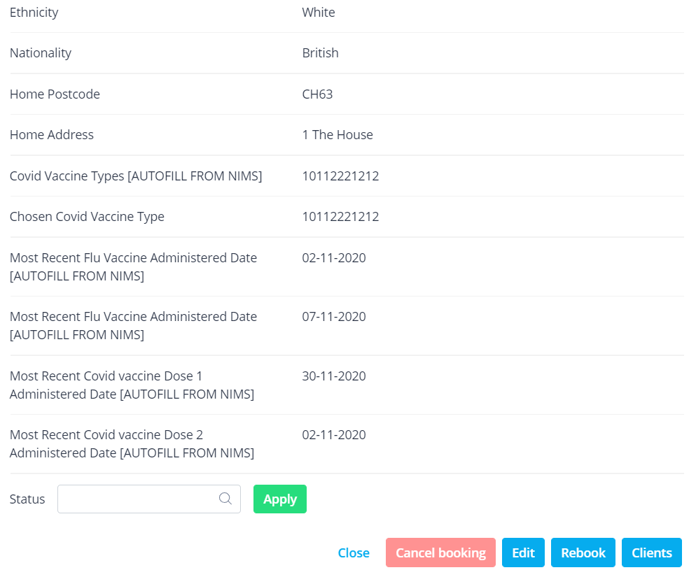
Click ‘Cancel’
A pop-up message will appear asking if you to confirm, click ‘Confirm’
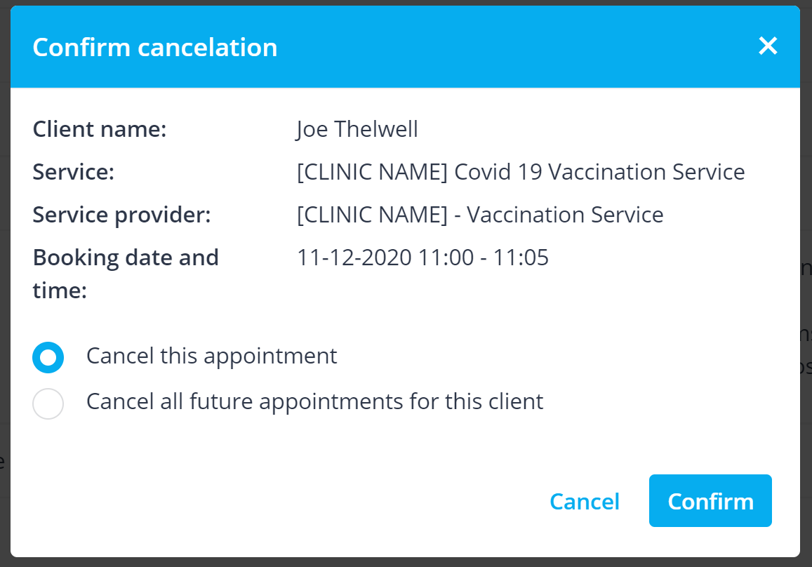
Users will receive a system generated cancellation notification email (if enabled).

